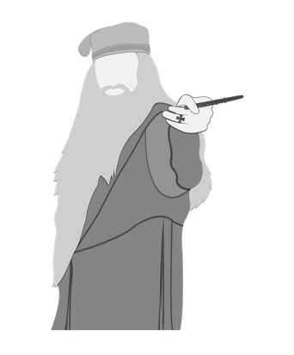
1. Read the following sentences to your partner and he/she tells you whether they are True or False.
- Dumbledore helps Voldemort. (No)
- Harry Potter lives with his aunt. (Yes)
- Remus is a werewolf. (Yes)
- Ron Weasley is rich. (No)
- Harry Potter's parents were killed by Dumbledore. (No, they were killed by Voldemort)
- Quidditch is a game. (Yes)
- Hermione´s parents are a muggles. (Yes)
2. Read the following text and decide whether the following sentences are True or False.
The Other Aunt
by Neonskittles98 (https://www.wattpad.com/user/Neonskittles98)

Anna wasn't angry. No. She was furious. Anna Lupin, formerly known as Anna Evans stormed the head master's office, her fury so powerful, her magic glowed around her. She stomped into the room with a nervous Remus behind her. Anna was a very sweet girl, but very smart, powerful, and strong willed. You did not want to get on her bad side. When her big sister, Lily, and her friend/honorary brother, James, died. She had been told that their son was also dead and promptly went into hiding. She did jobs for the ministry under the radar and ran a campaign for the fair treatment of werewolves in secret, but stayed underground. She became a sort of legend. Now, twelve years later not only does she find that her nephew is still alive, but also that he has already faced Voldemort in his first year as Professor Quirrell? No way was that gonna fly. She marched right up to the headmaster, "Alright Albus, you have exactly half a minute to tell me where my nephew is, before I go to Azkaban for the murder of a headmaster." Remus put hand on Anna's shoulder, "You don't have to threaten him, Ann. You're already scary enough without sticking your wand in his face. Breathe. Calm down. And if he doesn't cooperate after that, THEN you can blast him into oblivion, okay?" She pouted and put her wand up, "Fine." She sat down in the chair across from Dumbledore's desk and Remus sat next to her.
After a moment of awkward silence, she elbowed Remus, "Now what?" He shook his head, "Your always so polite and intelligent until you get angry. Why don't you try asking NICELY this time?" She shrugged, "Okay. Albus can you PLEASE tell me where you put my nephew before I go to Azkaban for the murder of a Headmaster?" She looked at Remus, feigning innocence, "Better?" He gave her a dry look, "No. Not particularly."
Their childish argument, was interrupted, "Well, doesn't this take me back? Miss Evans it's been years! You look well." Luckily after their short argument Anna was back to her calmer and more intelligent self, "Thank you, but it's Lupin now." She reached over and grabbed Remus' hand. Dumbledore's eyebrows rose, "Really? Well then, perhaps it's been longer than I thought." She sighed, "Albus, stop avoiding the question. Where is Harry?" He sighed and mumbled under his breath, "At your sister's house."
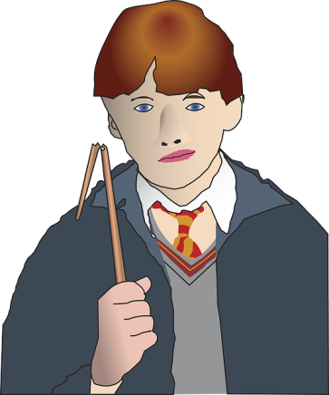
- Anna is Harry´s sister.
- At the beginning Anna is angry.
- Anna didn´t know that Harry was alive.
- Anna is single.
- Albus doesn´t know Anna.
- Remus likes Anna very much.
- Remus is a werewolf.
- Remus tries to calm Anna down.
- Translate as much of the text as possible:

3. Translate the following text:
Anna | wasn't | angry. | No. | She | was | furious.
Anna | Lupin, | formerly | known | as | Anna | Evans
stormed | the head | master's | office, | her | fury | so
powerful, | her | magic | glowed | around | her. | She
stomped | into | the room | with | a nervous | Remus | behind
her. | Anna | was | a very | sweet | girl, | but
very | smart, | powerful, | and | strong | willed. | You
did | not | want | to | get | on | her
bad | side.

4. Which of the red words mean the following:
extremely angry
Without attracting attention
a piece of wood used by magicians
Talk quietly and so that the others cannot understand you
clever and intelligent
to stop or make a break
Not easy to manage, uncomfortable
to become less excited or angry
To make someone angry with you
to say that you will do something bad to someone else
Absolutely not
before
not being guilty

5. Solve the crossword:
1.
2.
3.
4.
5.
6.
7.
8.
9.

CLUES
1. extremely angry
2. To make someone angry with you
3. Without attracting attention
4. Talk quietly and so that the others cannot understand you
5. clever and intelligent
6. Absolutely not
7. to stop or make a break
8. a piece of wood used by magicians
9. not being guilty

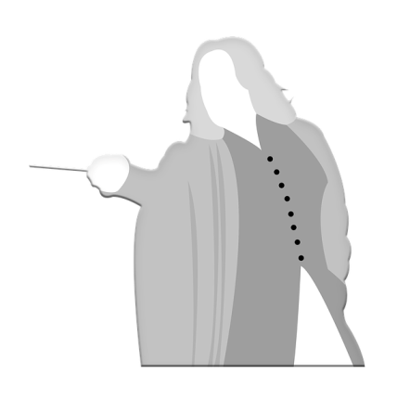
1. Read the following sentences to your partner and he/she tells you whether they are True or False.
- Professor Snape teaches Potions. (Yes)
- Hogwarts is the school for Wizards. (Yes)
- Draco Malfoy is Harry's friend. (No)
- Harry likes Professor Snape. (No)
- Voldemort wants to kill Harry Potter. (Yes)
- Sirius Black is Harry's uncle. (No, he is his godfather)
- Harry Potter is a normal boy. (No)

2. Read the following text and decide whether the following sentences are True or False.
The Other Aunt
by Neonskittles98 (https://www.wattpad.com/user/Neonskittles98)

Anna wasn't angry. No. She was furious. Anna Lupin, formerly known as Anna Evans stormed the head master's office, her fury so powerful, her magic glowed around her. She stomped into the room with a nervous Remus behind her. Anna was a very sweet girl, but very smart, powerful, and strong willed. You did not want to get on her bad side. When her big sister, Lily, and her friend/honorary brother, James, died. She had been told that their son was also dead and promptly went into hiding. She did jobs for the ministry under the radar and ran a campaign for the fair treatment of werewolves in secret, but stayed underground. She became a sort of legend. Now, twelve years later not only does she find that her nephew is still alive, but also that he has already faced Voldemort in his first year as Professor Quirrell? No way was that gonna fly. She marched right up to the headmaster, "Alright Albus, you have exactly half a minute to tell me where my nephew is, before I go to Azkaban for the murder of a headmaster." Remus put hand on Anna's shoulder, "You don't have to threaten him, Ann. You're already scary enough without sticking your wand in his face. Breathe. Calm down. And if he doesn't cooperate after that, THEN you can blast him into oblivion, okay?" She pouted and put her wand up, "Fine." She sat down in the chair across from Dumbledore's desk and Remus sat next to her.
After a moment of awkward silence, she elbowed Remus, "Now what?" He shook his head, "Your always so polite and intelligent until you get angry. Why don't you try asking NICELY this time?" She shrugged, "Okay. Albus can you PLEASE tell me where you put my nephew before I go to Azkaban for the murder of a Headmaster?" She looked at Remus, feigning innocence, "Better?" He gave her a dry look, "No. Not particularly."
Their childish argument, was interrupted, "Well, doesn't this take me back? Miss Evans it's been years! You look well." Luckily after their short argument Anna was back to her calmer and more intelligent self, "Thank you, but it's Lupin now." She reached over and grabbed Remus' hand. Dumbledore's eyebrows rose, "Really? Well then, perhaps it's been longer than I thought." She sighed, "Albus, stop avoiding the question. Where is Harry?" He sighed and mumbled under his breath, "At your sister's house."
- Anna is Harry´s sister.
- At the beginning Anna is angry.
- Anna didn´t know that Harry was alive.
- Anna is single.
- Albus doesn´t know Anna.
- Remus likes Anna very much.
- Remus is a werewolf.
- Remus tries to calm Anna down.
- Translate as much of the text as possible:
3. Translate the following text:
Anna | wasn't | angry. | No. | She | was | furious.
Anna | Lupin, | formerly | known | as | Anna | Evans
stormed | the head | master's | office, | her | fury | so
powerful, | her | magic | glowed | around | her. | She
stomped | into | the room | with | a nervous | Remus | behind
her. | Anna | was | a very | sweet | girl, | but
very | smart, | powerful, | and | strong | willed. | You
did | not | want | to | get | on | her
bad | side.

4. Which of the red words mean the following:
extremely angry
Without attracting attention
a piece of wood used by magicians
Talk quietly and so that the others cannot understand you
clever and intelligent
to stop or make a break
Not easy to manage, uncomfortable
to become less excited or angry
To make someone angry with you
to say that you will do something bad to someone else
Absolutely not
before
not being guilty

5. Solve the crossword:
1.
2.
3.
4.
5.
6.
7.
8.
9.

CLUES
1. extremely angry
2. To make someone angry with you
3. Without attracting attention
4. Talk quietly and so that the others cannot understand you
5. clever and intelligent
6. Absolutely not
7. to stop or make a break
8. a piece of wood used by magicians
9. not being guilty

